**Name : Akash Arjun Sawant**

**Email ID :** [**sawantakash106@gmail.com**](mailto:sawantakash106@gmail.com)

**Day 3 Project (AWS Essentials)**

**Solution :**

1. **Windows instance**

**IPv4 Public IP : 18.222.201.37**

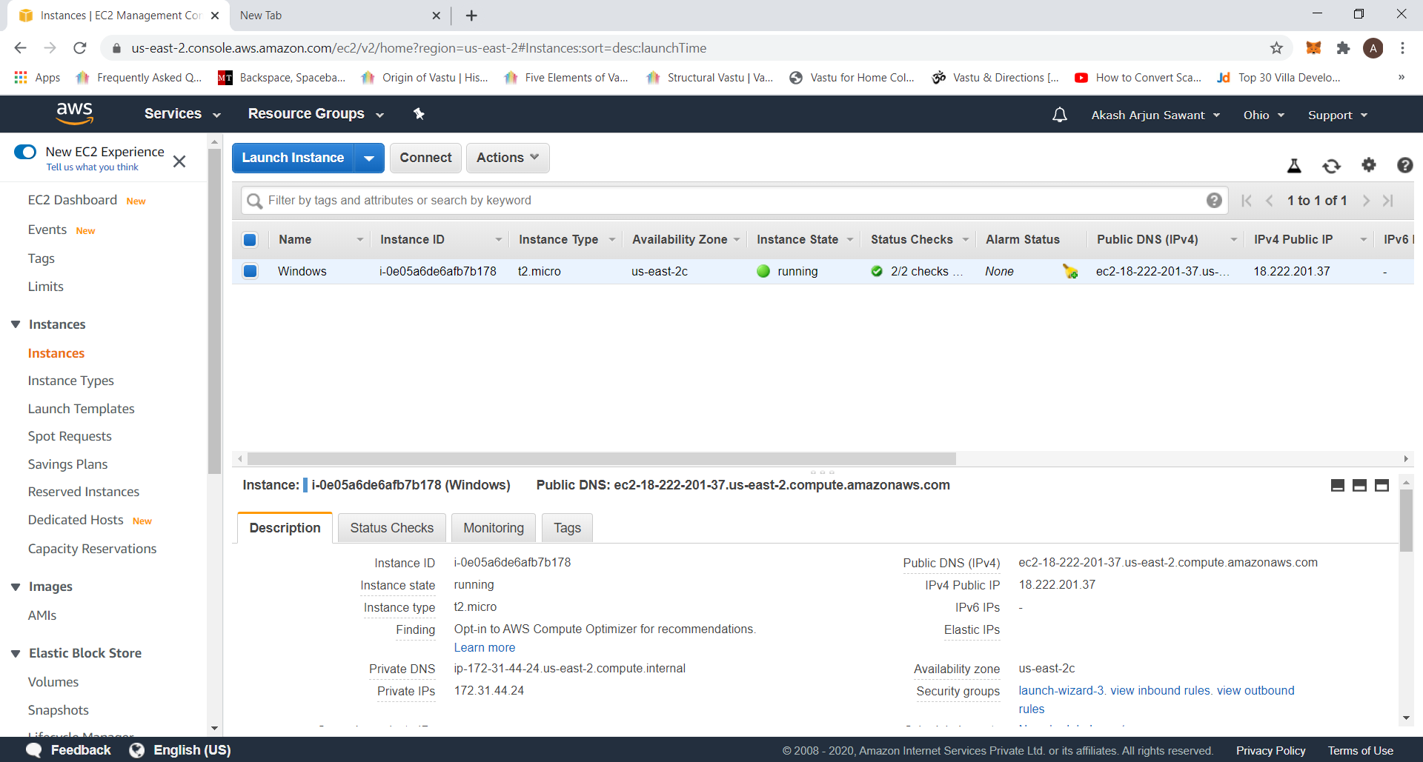

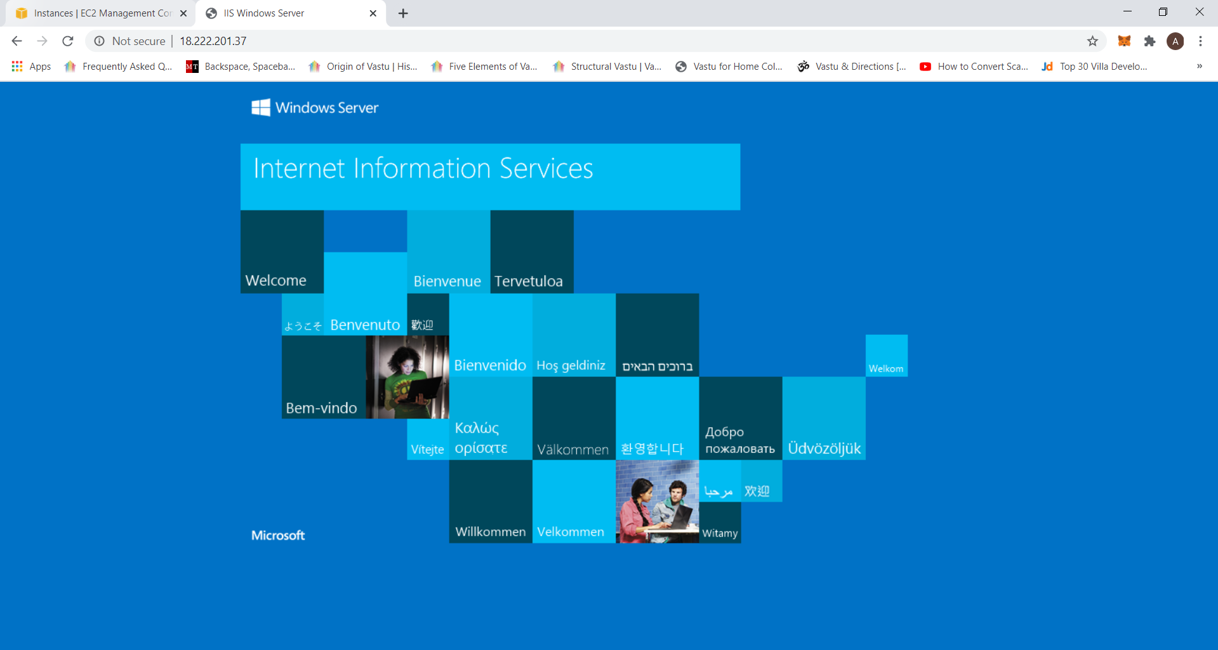

1. **Ubuntu instance**

**IPv4 Public IP : 18.222.7.76**

